SAP S4 Hana Security

SAP versions

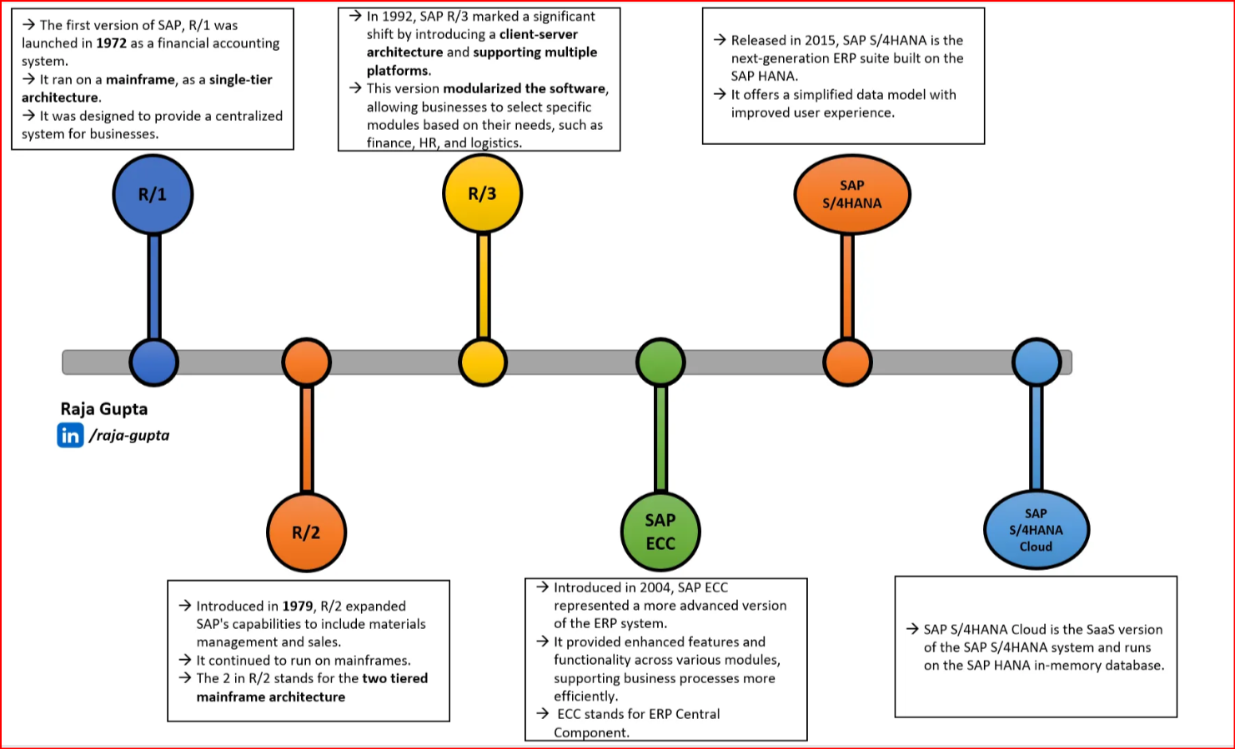

Introduction
It was 1972 when five former IBM employees set up Systems, Applications and Processing in Data Management — thankfully shortened to SAP, their intention was to “develop standard application software for real-time business processing. As of today, SAP is one of the largest independent software suppliers in the world.
1st Milestone — SAP R/1 (1972)
- The first version of SAP R/1 was launched in 1972 as a financial accounting system.
- It ran on a mainframe, as a single-tier architecture.
- It was designed to provide a centralized system for businesses.

SAP R/2 (1979–1990s)
- Platform: Mainframe-based
- Architecture: Centralized (mainframe), two-tier
- Key Use: Financial accounting, manufacturing, and supply chain on IBM mainframes
- Limitations: Not user-friendly; designed for large enterprises only
🔹 2. SAP R/3 (1992–2004)
- Platform: Client-server
- Architecture: Three-tier (Database, Application, Presentation)
- Key Modules: FI, CO, MM, SD, PP, HR
- Features:
  - GUI-based
  - More scalable and flexible than R/2
- Versions:
  - 4.7 (3.0 to 4.7 was the last of the R/3 series)
  - 4.7 was known as R/3 Enterprise
SAP R/2:
- Two-tier architecture:
- R/2 was designed with a two-tier structure, typically consisting of a presentation layer and a database/application layer running on a mainframe computer.
- Mainframe-based:
It was primarily designed to run on large mainframe systems, which were common in the 1980s and early 1990s.
- Limited scalability and flexibility:
Due to its architecture, R/2 had limitations in terms of scalability and flexibility compared to later client-server based systems.
SAP R/3:
- Three-tier architecture:
R/3 introduced a three-tier architecture, separating the presentation, application, and database layers into distinct tiers.
- Client-server model:
- This architecture allowed for a client-server model, with the presentation layer running on individual user workstations (clients) and the application and database layers running on separate servers.
- Improved scalability and flexibility:
The three-tier architecture of R/3 provided significant improvements in scalability, allowing it to handle larger workloads and adapt to changing business needs.
- Multi-platform support:
R/3 was also designed to be compatible with multiple platforms and operating systems, expanding its reach to a wider range of businesses.
- Real-time data processing:
The "R" in R/3 stood for "Real-time data processing," emphasizing its ability to handle data in real-time.
🔹 3. SAP ERP (2004–2015)
- Based on: SAP R/3 4.7
- Key Release: SAP ERP Central Component (ECC)
- Architecture: Still three-tier but modernized
- Enhancement Packs (EHPs): Regular updates with new features (EHP1–EHP8)
- Key Version: SAP ECC 6.0 (widely adopted globally)
- Limitations: Relational database-based; performance bottlenecks with large data
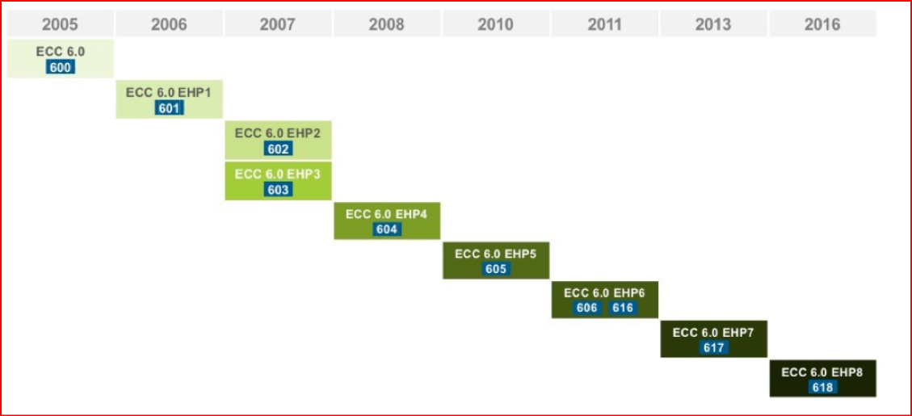
🔹 4. SAP S/4HANA (2015–Present)
- Platform: SAP HANA (in-memory database)
- Architecture: Simplified data model, cloud-first approach
- Two Editions:
  - S/4HANA On-Premises
  - S/4HANA Cloud
- Key Benefits:
  - Real-time analytics
  - Fiori UI (modern web-based UX)
  - Reduced data footprint
  - Embedded AI and machine learning
- Major Releases:
  - 1511 (initial), 1610, 1709, ..., 2023
  - Annual release cycle (on-premise)

